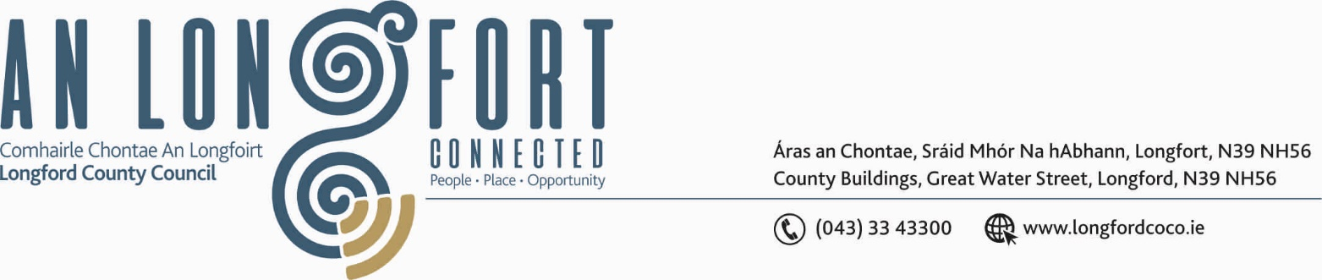

BALLYMAHON MUNICIPAL DISTRICT

17th July 2020.

To: Each Member of Ballymahon Municipal District.

Dear Member,

You are requested to attend Meeting of Ballymahon Municipal District to be held in Ballymahon Community Library on Thursday, 23rd July 2020 at
4.00 p.m. to transact business, as set out on the Agenda hereunder.

Yours sincerely,
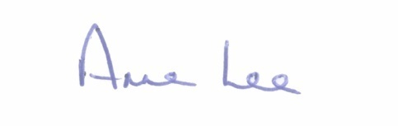

_______________
Anne Lee,
Meetings Administrator.

AGENDA

Prayer before meeting.

1. Confirmation of Minutes of the following Ballymahon Municipal District Meetings – copies enclosed.

- Committee Meeting held on the 14th May 2020.
- Municipal District Meeting held on the 14th May 2020.
- Annual Meeting held on the 18th June 2020.

2. Matters arising from Minutes.

3. Declaration of Interest by Members.

4. Management Report - enclosed.

5. Notice of Motion submitted by Councillor Seamus Butler to the March meeting of the County Council -

“That Longford County Council should provide serviced overnight facilities for RUVs and camper vans. This will mitigate against the blight of such vehicles causing nuisance by parking in public areas such as Clondra Harbour. It will also attract a category of tourist that is not currently catered for adequately in the County.”

It was agreed that this Notice of Motion be referred to each of the Municipal Districts.

6. Notices of Motions, submitted by Councillors, as listed hereunder –

Councillor Paul Ross.
“That the entrance wall into Auburn Park , Edgeworthstown be repaired as a matter of urgency.”
“That a Dereliction Notice be placed on the burned out house in Auburn Park which is over 12 months in ruins.”
“That speed ramps be installed in Devine Crescent and Auburn Park in the interest of child safety.”

Councillor Pat O’Toole.

“I call on Longford County Council / Transport Infrastructure Ireland to erect a flashing speed limit sign on the N55 on the Edgeworthstown approach road to Ballymahon at Ballymahon GAA grounds in the interest of public safety.”

“I call on Longford County Council and ESB Networks to provide a fast charging point for electric vehicles at a location in Ballymahon to be agreed.”

Councillor Colm Murray.

“I call on Longford County Council to erect new signage along the Royal Canal Greenway from Clondra to the border with Westmeath. The signage would include indicated distance to the next/nearest town or village and information about some of the amenities and hospitality/tourist related businesses in the vicinity of the Greenway.”



